1. environment

Server：

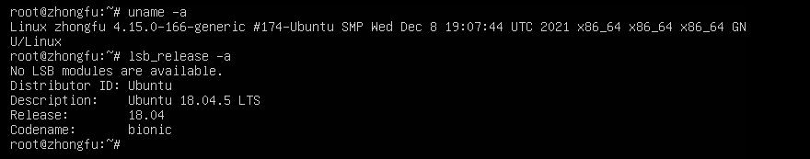software version：

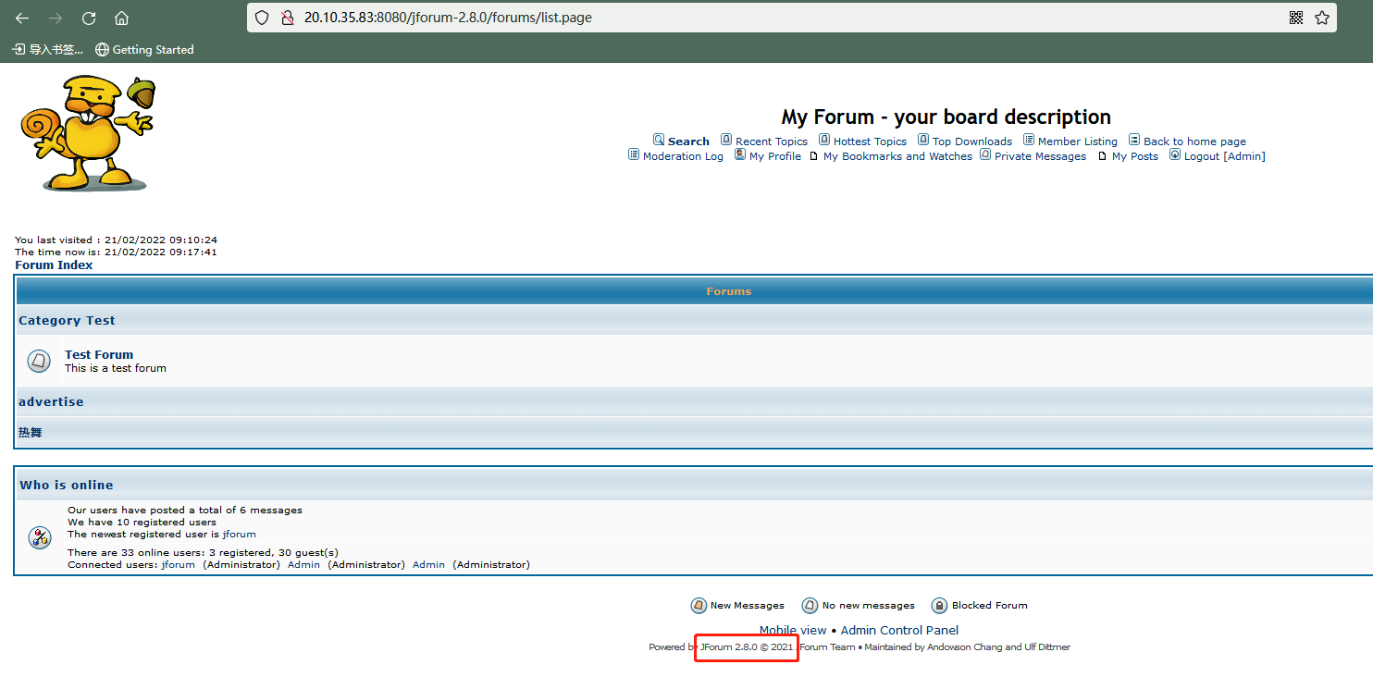

1. tool

* Burpsuite

1. Steps
2. Install JForum 2.8.0and init ，then access the main page.

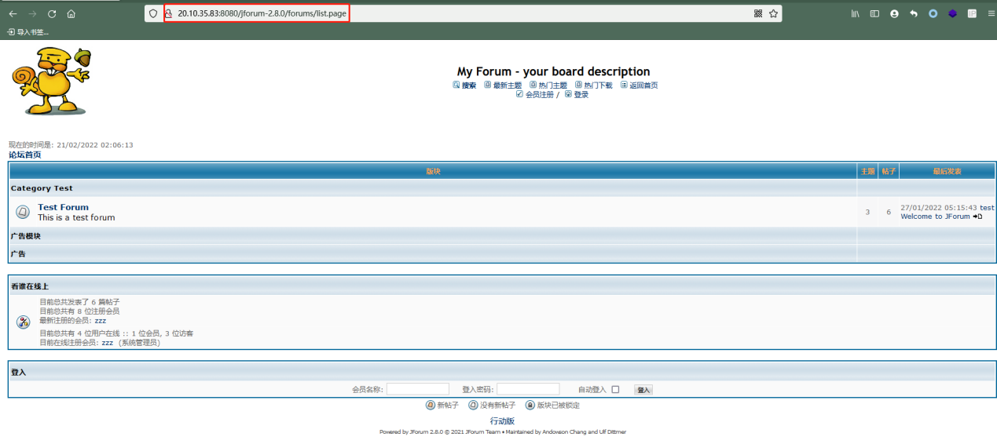

1. Admin login in, open POC.html with browser(like firefox、chrome),click

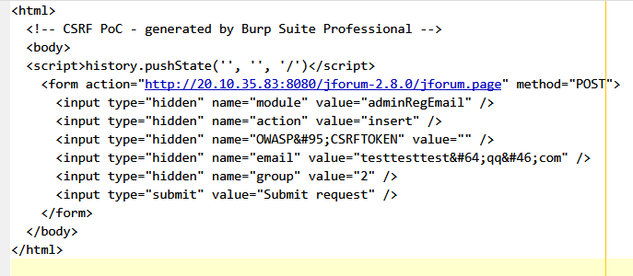

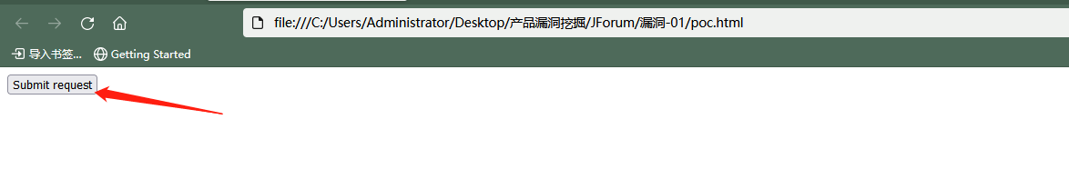

1. Then you can see following:

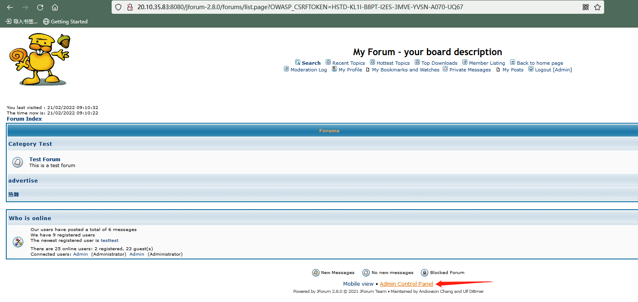

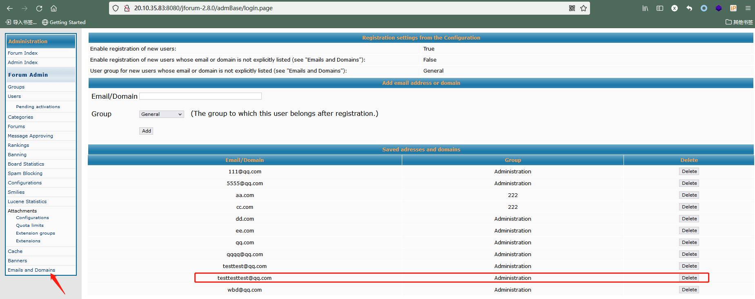

1. Register a new user，[mail address is testtesttest@qq.com](mailto:邮箱地址填写为testtest@qq.com)，you are a administrator.

